**STR**

Website Project

YOUthDuo""

<https://youthduo.com/home>

Report writer's name: Nina Arkus

Approved by: Mr. Kobi Yonasi

Edition number: 0.1

Edition date: 2022

Table of contents

1. General 3

1.1 Website Definition **3**

2. Execution of system tests 3

2.1 Description of performed website tests **3**

2.2 Summary of performed website tests **4**

3. Performing system tests 5

3.1 Reporting faults by rounds **5**

3.2 Number of faults by severity level **5**

3.3 Reporting faults by status **6**

4. Evaluation of system quality 7

4.1 Faults status in the examined website **8**

4.2 Risks and Recommendations **8**

5. Suggestions for improvement 9

6. Appendices 10

6.1 Similar websites suggestions **11**

1. General

The purpose of this document is to summarize the tests results and to supply additional value based on these results.

These document results allows the user/project manager to decide whether to pass the system to the next level.

* 1. Website Definition

The website "YouthDuo" <https://youthduo.com/home> was founded by Jami Lin.

Its target users are mostly women but also men.

In this website we are able to see:

* Information about Jami Lin's cosmetic products.
* Information about the organic and vegan ingredients her products consists.
* Purchase Jami Lin's cosmetic products.
* Customers reviews.
* Free YouTube tutorials about skincare and anti-aging tips.

1. Execution of system tests
   1. Description of performed website tests

I checked the site on different platforms ( Mobile , Chrome and Microsoft Edge).

I used exploratory testing in this project , with a checklist that was given by the project manager to ensure that all the tests are being covered.

All the tests were manual tests.

The main tests that were performed are:

‏✔ GUI

✔ Functionality

✔ Usability

✔ Compatibility

✔ Accessibility

* 1. Summary of performed website tests

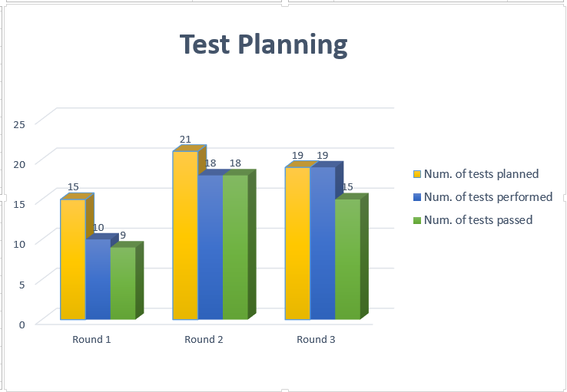The following table gathers the number of tests that were planned and performed for each testing round.

|  |  |  |  |  |  |
| --- | --- | --- | --- | --- | --- |
| Round number | Num. of tests planned | Num. of tests performed | Percentage of tests performed | Num. of tests passed | Percentage of tests passed |
| First | 15 | 10 | 67% | 9 | 60% |
| Second | 21 | 18 | 86% | 18 | 100% |
| Third | 19 | 19 | 100% | 15 | 79% |

Tests that did not executed due to lack of time, resources and lower priority:

✔ Load

✔ Recovery

✔ Integration

1. Performing system tests
   1. Reporting faults by rounds

The next table include the number of bugs that have been reported during each testing round , sorting them by their severity level.

Definition of severity level:

**Critical level –** The function/process that has been checked doesn’t perform as it should and can cause serious damage to other function/process/data.

**Medium level –** The function/process that has been checked doesn’t perform as it should but doesn’t cause any damage to other function/process/data. For example : broken links.

**Low level –** The function/process that has been checked is performing as it should but needs to be improved. For example: A GUI improvement such as small font.



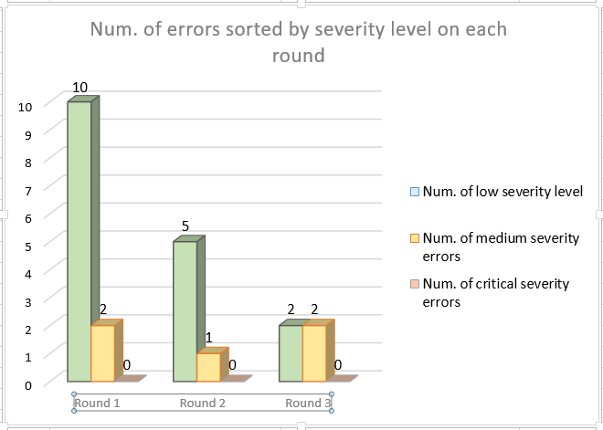

* 1. Number of faults by severity level

Critical severity errors haven't been found in this website.

Most of the bugs are related to page content , design , and some functions in the website.

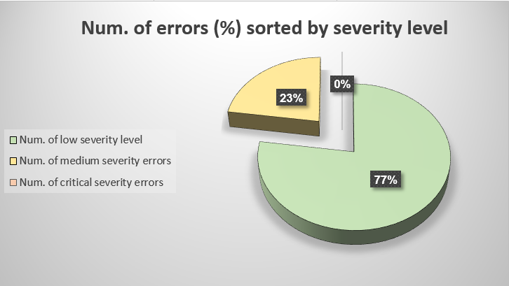

* 1. Reporting faults by status

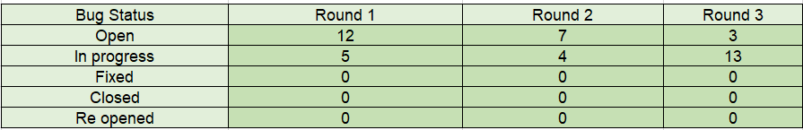

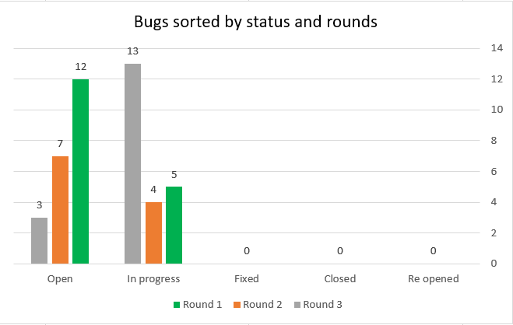

1. Evaluation of system quality
   1. Faults status in the examined website

This table represents the summary of all the open faults sorted by their severity level.

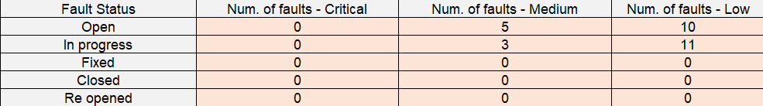

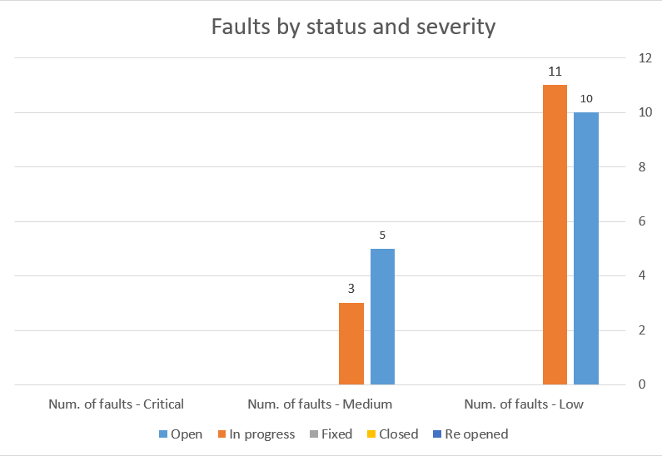

* 1. Risks and Recommendations

After an extensive examination of the website in number of different platforms and by checking the most main and relevant tests, there hasn't been found any critical errors.

The errors that have been found deteriorate the UX (User Experience), and can cause a loss of many clients if left untreated.

Therefore, my recommendation is that there should be a delay in uploading the site.

1. Suggestions for improvement
   1. To catalogue the different options in the navigation bar in a better understandable way so the user won't be confused.
   2. The website should be in a minimalistic design. Most of the information should be categorized by the different options in the navigation bar.
   3. Each page should have the same layout.
   4. The navigation bar should have minimal options.
   5. The site should have at least one option for other language that is common in the USA such as Spanish.

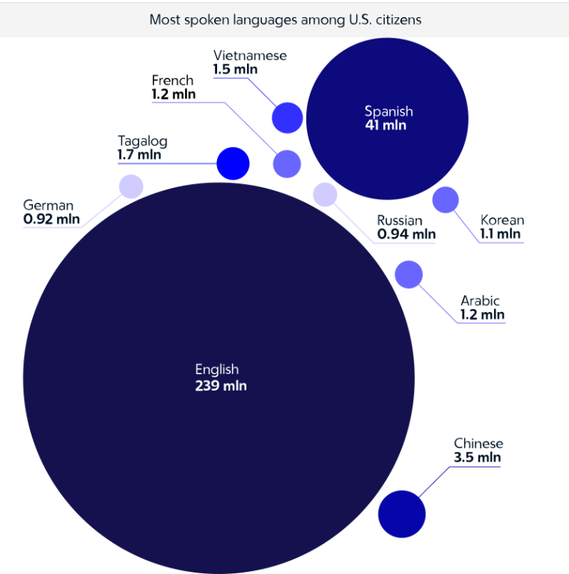

* 1. Full written information about the product should appear in the relevant page.
  2. There should be a "Store" option that includes all the skincare products.
  3. Provide sufficient contrast using colors and textures.
  4. Allow manual font size adjustment for users with a poor vision.

5.10 All the information about the site owner such as - name, email, and phone number should appear in “About us” or “Contact” tab.

5.11 Text and tables should be aligned properly.

5.12 There should be an icon in the left upper corner to go back to the homepage

5.13 Either all links will open the actual site, or delete the icons of Twitter, LinkedIn and Pinterest.

5.14 Choosing a better "catchy" name for the company.

5.15 Make a collaboration with well-known beauty bloggers and send them examples to try on – to get more advertisement.

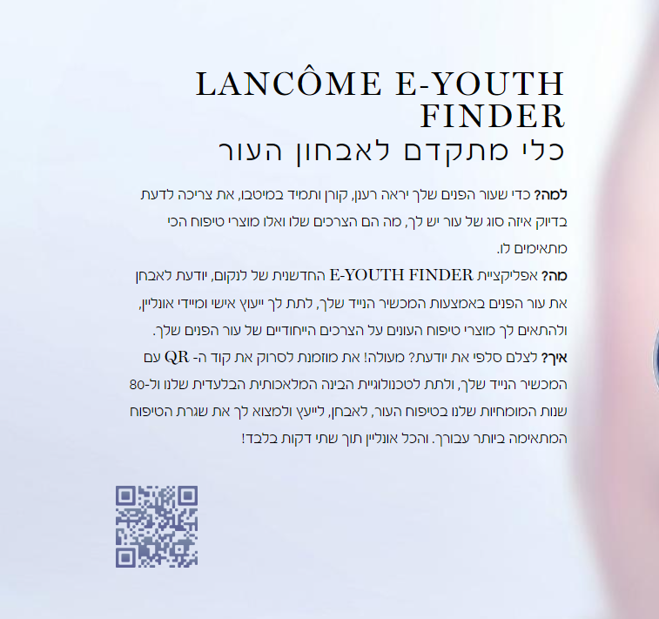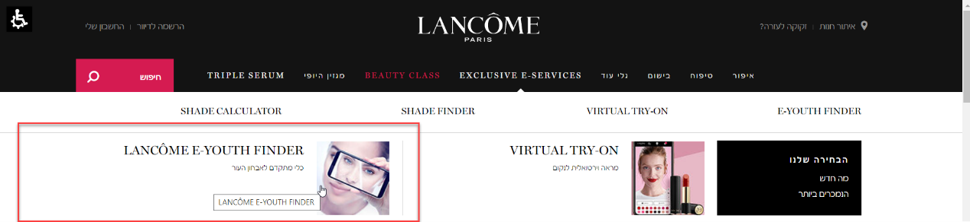5.16 The website should have a quick skin diagnosis – for example

1. Appendices
   1. Similar websites suggestions

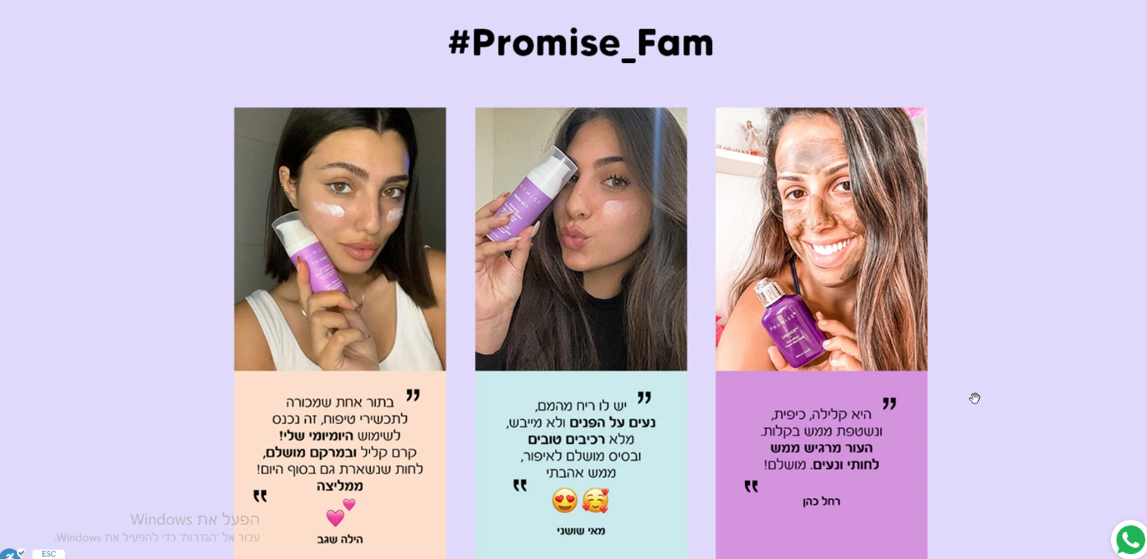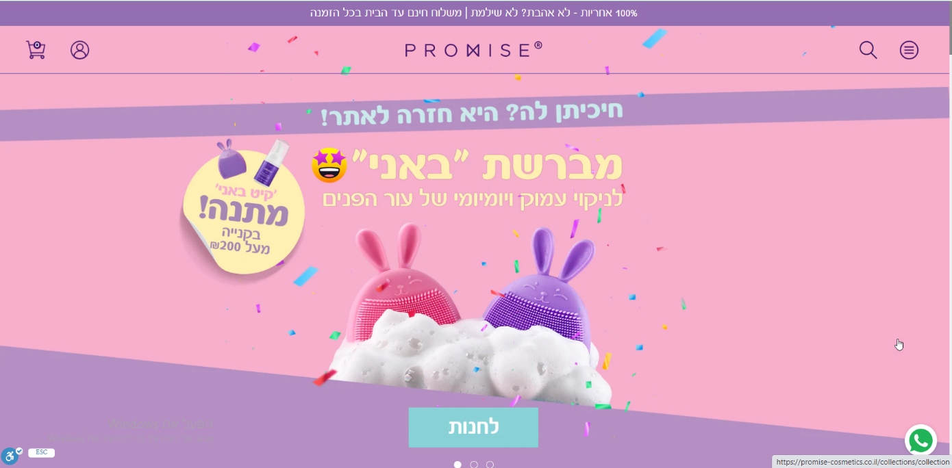<https://promise-cosmetics.co.il/>

**Differences**: This site has the navigation bar hidden from the right side of the page making the site to look more "clean" and user friendly.

The colors and the graphics are flattering to the eye.

At the homepage there is all the information the user needs even without clicking on the menu.

From the homepage the user can reach reviews, store and product information.

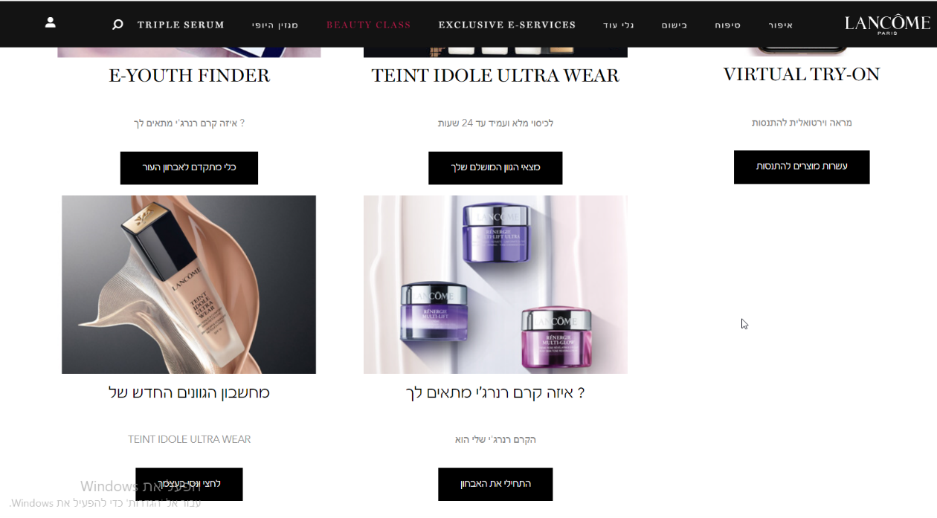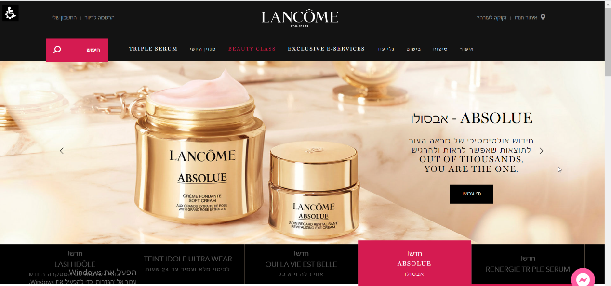<https://www.lancome.co.il/>

**Differences**: This site has a short minimalistic homepage, with a navigation bar at the top but with less options to choose so the user won't get confused. There is a simple design of mostly black and white colors.

The main thing about this site is their multiple examination tools for skincare and makeup in order to match each individual client by asking her questions about her skin or upload a photo of her and with the help of an application with artificial intelligence the client can get a perfect match.

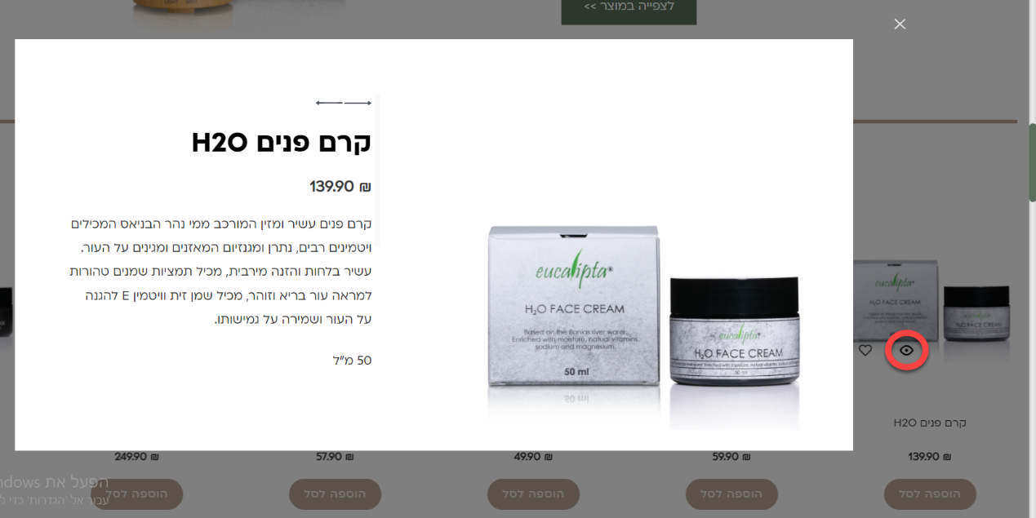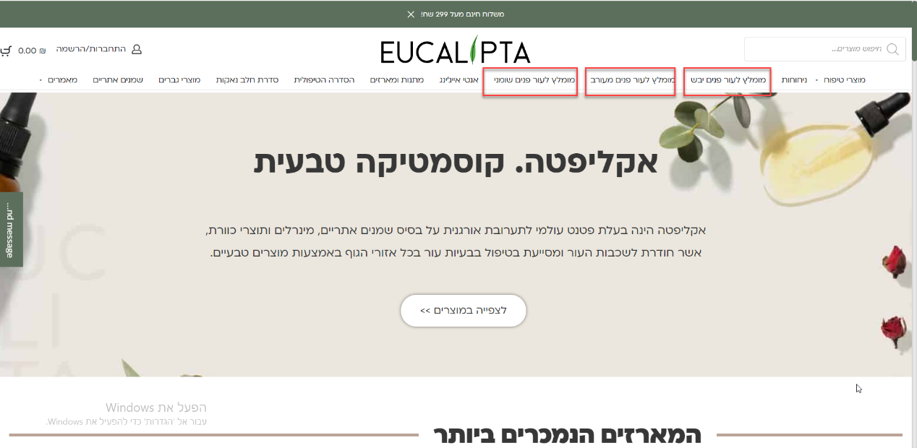<https://www.eucalipta-deadsea.com/>

**Differences:** This site has multiple choices in the navigation bar but they are very clear and understandable for the user. Unlike the "Lancôme" site which had examination tools for the clients , this site has already categorized the recommended products for each skin type.

The site also uses light and simple design which looks good.

Also at the homepage you can do a quick overview of a product you're interested in and it will open a window with the information about the product, which makes the site user friendly.